Let’s walk through whole process:

1. Sign in to power automate,

* Make sure you have a student or business account
* Login your outlook

1. Click “Create” and select "Cloud Automate”

1. Give a flow name

1. Select “When a new email arrives (V3)” and click “Create”

1. Click the flow name you just create, then select “Inbox” for the folder

1. Retrieve file attachment from the folder, click “Add Action” and search “get attachment”

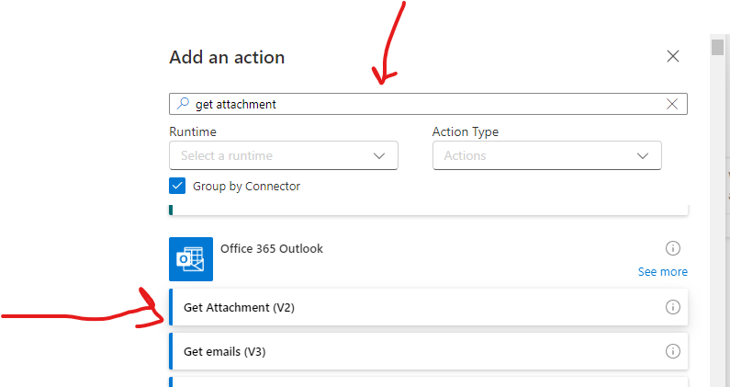

1. Select Message ID and Attachment ID

1. Click on “add action” and search “Cloudmersive”. In this step API key is needed.

1. After the previous step, you flow should be like the following:

1. Save the flow, test and run the flow.